

**Name**: Ahmed said sayed abo el ala

احمد سعيد سيد ابوالعلا

# Sec:4 N.B:2 Number of site:70

**Subject:** comouter architecture

I choice this project because Although the term computer architecture sounds very complicated, its definition is easier than one might think. Computer architecture is a science or a set of rules stating how computer software and hardware are joined together and interact to make a computer work. It not only determines how the computer works but also of which technologies the computer is capable. Computers continue to be a major part of our lives, and computer architects continue to develop new and better programs and technologies.

Code

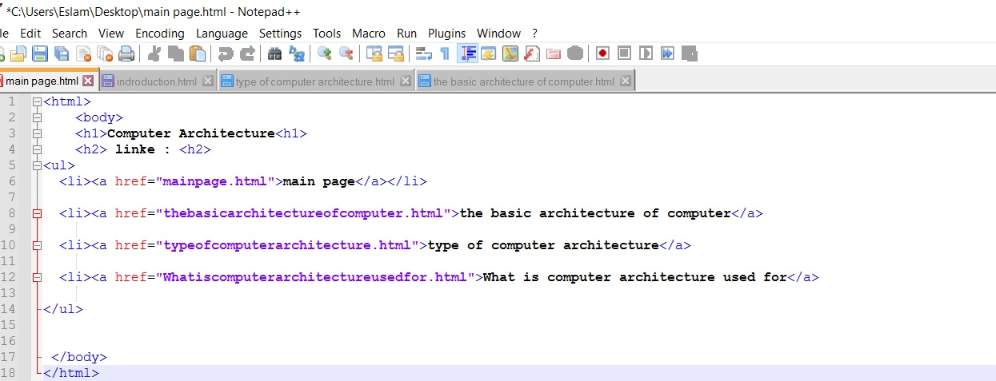

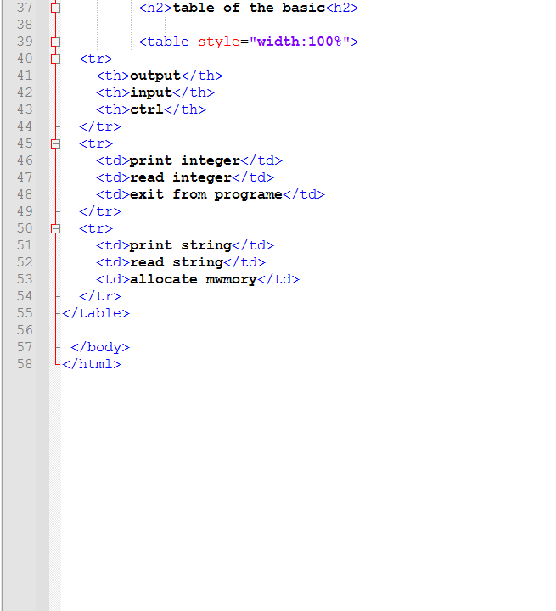

**screenshot**

